Table of Contents

[1. Description 2](#_Toc496234593)

[2. Control Description 2](#_Toc496234594)

[3. Interface Sketch 2](#_Toc496234595)

[I. Initial Scene Start 2](#_Toc496234596)

[II. Game over UI 3](#_Toc496234597)

[4. Screen Description 3](#_Toc496234598)

[I. Initial Scene Start State 3](#_Toc496234599)

[II. Gameplay State 4](#_Toc496234600)

[4](#_Toc496234601)

[III. Game over State 4](#_Toc496234602)

[5. Enemies 5](#_Toc496234603)

[6. Scoring 5](#_Toc496234604)

[7. Sound Index 5](#_Toc496234605)

[Eyeball Death 5](#_Toc496234606)

[Red UFO Death 5](#_Toc496234607)

[Coin Collected 5](#_Toc496234608)

[Laser shot 5](#_Toc496234609)

[8. Art/Multimedia Index 6](#_Toc496234610)

[Background 6](#_Toc496234611)

[Player UFO Exploding Eyeballs 6](#_Toc496234612)

[Red UFO ENEMY Coin 6](#_Toc496234613)

## Description

This is a side-scrolling game. You control a blue UFO spacecraft whose main objective is to get the highest score while avoiding the enemies coming towards you. If the enemies collide with the blue UFO the player will lose a life. When the life count reaches 0 the blue UFO is destroyed and the game is over. The player will see their score and can press the reset button to reload the scene.

The blue UFO can move in any directions and can shoot blue lasers to destroy any incoming enemies. The blue laser is instantiated each time it is shot and is destroyed when it collides with an enemy or move past the screen.

## Control Description

**WASD** – Movements for the blue UFO

**SPACE** – Shoot blue lasers

## Interface Sketch

### Initial Scene Start

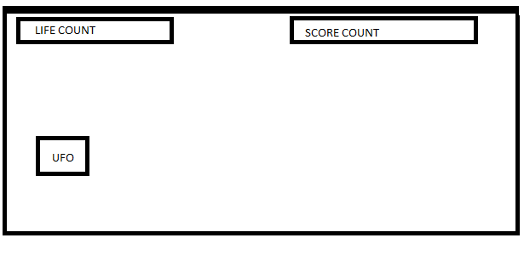

### Game over UI

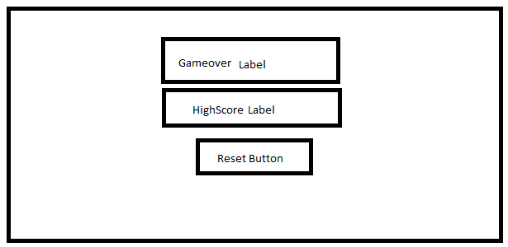

## C:\Users\PC\Desktop\GameStart.PNGScreen Description

### Initial Scene Start State

### Gameplay State

### C:\Users\PC\Desktop\CurrentGame.PNG

### Game over State

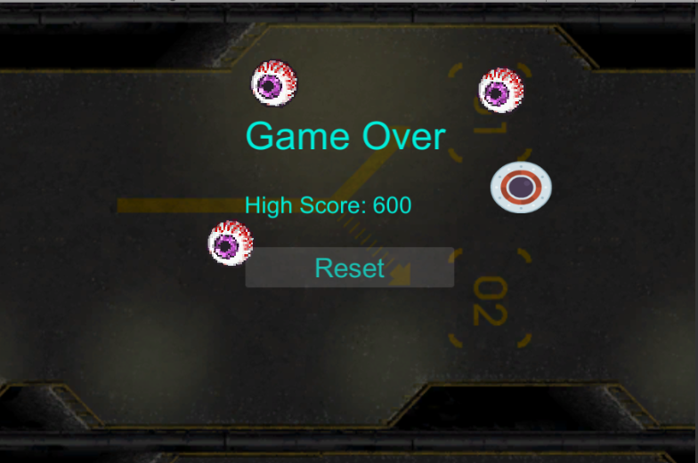

## Enemies

There are two types of enemies. First are the five exploding eyeballs. They spawn randomly before the screen and move in a diagonal line towards the player direction. Second are the two red UFOs. They initially spawn at the same spot in opposite direction of each other. Afterward they move either up or down and then straight down towards the line.

## Scoring

The only way to get a score in this game is to collect the golden coins. Each time a coin is collected the player gain 100 points. The coin moves down in one direction. The coin will respawn in a random position once the player collects the coin or if the coin moves past the screen.

## Sound Index

### Eyeball Death



### Red UFO Death



### Coin Collected



### Laser shot



## Art/Multimedia Index

### I:\ProgrammingStorage\Unity\SideScrollerGame\Assets\Sprites\Background\background_back_square 1.pngBackground

### Player UFO Exploding Eyeballs

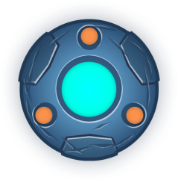

### I:\ProgrammingStorage\Unity\SideScrollerGame\Assets\Sprites\Other\CoinSprite.pngRed UFO ENEMY Coin

